ECE 233
Laboratory Experiment 1
Learning Basic Measurement Techniques

Voltage Measurement: Voltage in a circuit is always measured across an electrical component. Hence it should be connected in parallel with the electrical component. It is also possible to measure the potential (voltage) difference between any two points (nodes) in a circuit. For this purpose, the probes of the multimeter are connected to these two points. Generally it is a convention to put the black (negative) probe to the node where potential is (assumed to be) lower and red (positive) probe to the node where potential is higher. However when the opposite of these connections is done (red probe to lower potential and black probe to higher potential) the measurements readings will be negative if a digital multimeter is used as a voltmeter. When an analog multimeter is used with opposite connection configuration, we’ll probably not able to measure any voltage value. Check Figure 1 for the connection of a multimeter as a voltmeter across resistor R₁ (or between nodes A and B) in a circuit.
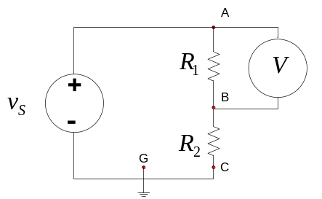
Figure 1: A Multimeter connected as a Voltmeter.

The internal resistance of a voltmeter is very high (ideally it is infinite). Thus nearly all the current will over the circuit element when the voltmeter is connected in parallel. Hence the potential loss over the resistor due to connection of the voltmeter will be vey negligible (if the resistance of the voltmeter is infinite the potential loss over the resistor will be nearly equal to 0).

- Construct the circuit in Figure 2 on the breadboard. The parameters of the circuit are as follows: R₁ = 1 kΩ, R₂ = 1 kΩ, R₃ = 2.7 kΩ and V_{S} = 10 Volt DC (DC voltage will be supplied from the DC power supply). Using both the analog and digital multimeters perform voltage measurements across different points (nodes) of the corresponding circuit. The details for different connections over the same circuit are given in Table 1. Fill up this table. If a measurement is not observed than put ‘X’ for that measurement on the table. In your measurements choose a suitable voltage measurement range (for example 10 Volt DC voltage measurement range).

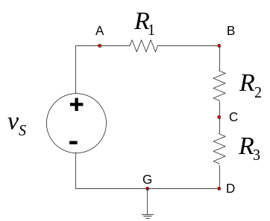
Figure 2: Circuit for voltage measurements.

Table 1: Table for Voltage measurements

Measurement | Points |  | Voltage measurement using digital multimeter
Measurement | Black probe  (negative probe) | Red probe (positive probe) | Voltage measurement using digital multimeter
1 | G | A
2 | G | B
3 | G | C
4 | G | D
5 | G | G
6 | C | A
7 | C | B
8 | C | C
9 | C | D
10 | C | G
11 | A | A
12 | A | B
13 | A | C
14 | A | D
15 | A | G
16 | D | C
17 | C | B
18 | B | A
19 | B | C

Questions:
- What happens when the leads of the multimeter are interchanged?
- Based on the measurements 15 to 18 can we say that the sum of the voltage drops across each circuit element (resistors) is equal to the battery voltage (V_{S} = 10 Volt)
- What is the ground point on this circuit?
- What will happen to the voltages across the other resistors if R₃ is removed from the circuit?
- Have you measured any voltage across any of the resistors? If your answer is YES which resistors? Also write down the voltage measurements you have performed for these resistors?

Current measurement: In order to measure current for a component in a circuit, the Multimeter should be connected in series with the component. Generally it is a convention to put the red (positive) probe to the node where current is coming from and black (negative) probe to the node where the current is flowing. However when the opposite of these connections is performed (red probe to current going direction and black probe to current coming direction) the measurements readings will be negative if a digital multimeter is used as an Ampermeter. When an analog multimeter is used with opposite connection configuration, we’ll probably not able to measure any current value. Check Figure 3 for the connection of a Multimeter as an Ampermeter over resistor R₁ in a circuit.

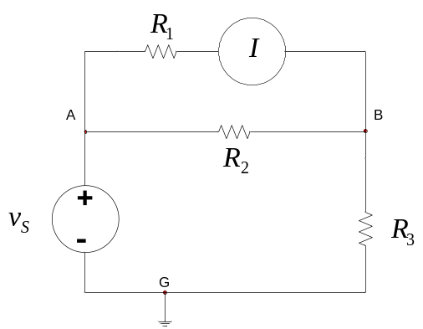

Figure 3: A Multimeter connected as an Ampermeter.

The internal resistance of the Ampermeter is generally very small (ideally it is equal to 0). For this reason, the decrease of the actual current value due to the connection of Ampermeter due to series connection is negligible (zero for the ideal case).

  - Construct the circuit in Figure 4 by using two digital Multimeters. Use one of them as Voltmeter and the other one as Ampermeter. The parameters of the circuit are as follows: R₂ = 1 kΩ, R₃ = 1 kΩ and V_{S} = 10 Volt DC (DC voltage will be supplied from the DC power supply). R₁ will take two different values (either 100 Ω or 1 kΩ) in different measurements. According to the different R₁ values and different multimeter connection configurations in Table 2, construct the circuits and perform the current and voltage measurements.

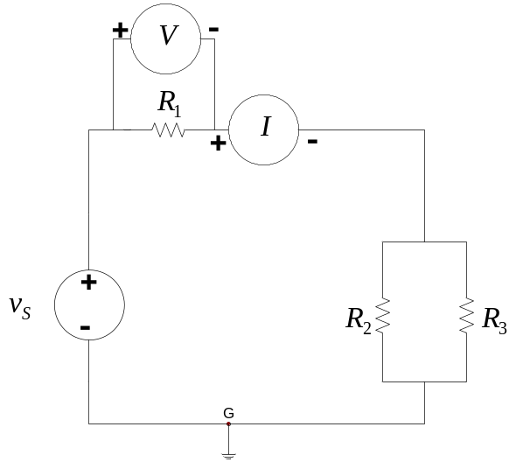
Figure 4: Circuit for current-voltage measurements.

Table 2: Table for voltage-current measurements.
 | Current | Voltage | R₁ | Voltmeter | Ampermeter
1 |  |  | 1kΩ | *Normal | *Normal
2 |  |  | 1kΩ | Normal | Reversed
3 |  |  | 1kΩ | Reversed | Normal
4 |  |  | 1kΩ | Reversed | Reversed
5 |  |  | 100Ω | Normal | Normal
6 |  |  | 100Ω | Normal | Reversed
7 |  |  | 100Ω | Reversed | Normal
8 |  |  | 100Ω | Reversed | Reversed

* If the probes are normal, it is connected as shown in Figure 4. If it is reversed the polarities of the probe connection should be reversed.

  - Construct the circuit in Figure 5 by using two digital Multimeters. Use one of them as Voltmeter and the other one as Ampermeter. The parameters of the circuit are as follows: R₂ = 1 kΩ, R₃ = 1 kΩ and V_{S} = 10 Volt DC (DC voltage will be supplied from the DC power supply). R₁ will take two different values (either 100 Ω or 1 kΩ) in different measurements. According to the different R₁ values and different multimeter connection configurations in Table 3, construct the circuits and perform the current and the voltage measurements.

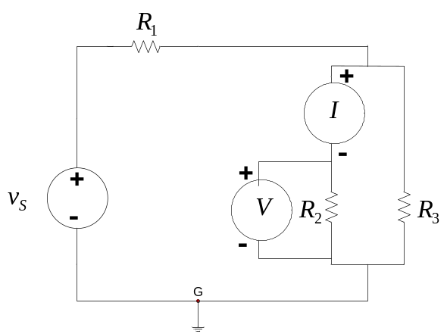
Figure 5: Circuit for current-voltage measurements.

Table 3: Table for voltage-current measurements.
 | Current | Voltage | R₁ | Voltmeter | Ampermeter
1 |  |  | 1kΩ | *Normal | *Normal
2 |  |  | 1kΩ | Normal | Reversed
3 |  |  | 1kΩ | Reversed | Normal
4 |  |  | 1kΩ | Reversed | Reversed
5 |  |  | 100Ω | Normal | Normal
6 |  |  | 100Ω | Normal | Reversed
7 |  |  | 100Ω | Reversed | Normal
8 |  |  | 100Ω | Reversed | Reversed

* If the probes are normal, it is connected as shown in Figure 5. If it is reversed the polarities of the probe connection should be reversed.

Resistance measurement: Resistance of a component is always measured when it is not connected to any circuit (without any connection to the power source and other circuit components), otherwise the resistance measurement will be wrong. In order to make a resistance measurement, disconnect the resistor from the circuit, switch the multimeter to resistance measurement and than connect the multimeter probes (both of the probes) to the resistor from its terminals (the polarity of the probes are not important for resistance measurements). When the resistor is connected to the multimeter, the battery inside the multimeter will produce a voltage. Since this multimeter-resistor configuration is now a new circuit, a current will also be observed as the result of the applied voltage. Multimeter internally takes the ratio of the provided voltage to the induced current and it measures the resistance value for the resistor.

  - Construct the circuit in Figure 6 (without connecting any power supply to the circuit between terminals A and E). Fill up Table 4 (rows 1 to 6), according to the resistance measurement configurations.
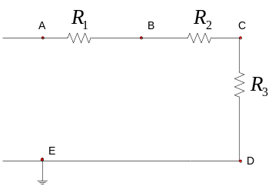

Figure 6: Circuit for resistance measurements.

  - Now connect 10 Volt DC source as in Figure 7 (using the DC power supply) between nodes A and E (A positive part, E ground part). Now measure the resistance value between nodes D and C (rows 7 and 8 of Table 4).

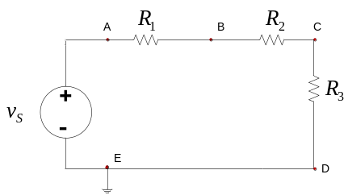
Figure 7: Circuit for resistance measurements (with power supply)

The resistor values are: R₁ = 1 kΩ, R₂ = 10 kΩ, R₃ = 2.2 kΩ

Table 4: Resistance measurements

 | Nodes (points) |  | Resistances
 | Black probe | Red probe | Digital Multimeter
1 | D | C
2 | C | D
3 | A | B
4 | B | A
5 | B | C
6 | C | B
7 | D (power on) | C (power on)
8 | C (power on) | D (power on)

Questions:
- What happens when the probes of the multimeter (for resistance measurements) are interchanged?
- What happens to the resistance measurements when external power is applied to the system as the resistance measurement task is continuing?
- Is it possible to measure the resistance values soundly when external power is provided to the circuit?
- Indeed, no power is applied to the experimental setup for resistance measurements at the first six measurements (shown in Table 6). However, it is possible to measure the resistance values precisely? How can this happen (that means how can the multimeter measure the actual resistance values although no power is applied to the circuit from the power supply)

Using Ohm’s law to find the resistance value: Ohm’s low states that, the voltage versus current characteristics is a linear relation for a linear time invariant resistor and the ratio of the voltage to the current value for this reason is constant and it is called as the resistance. Hence Ohm’s law is given by the formula,

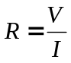 (1)
where ‘V’ is the voltage measured in Volts across the resistor in Volts, ‘I’ is the current measured through the resistor in Amperes and ‘R’ is the resistance in Ohms (Ω).

Power calculation for a resistor for DC excitation : The power dissipated over a resistor for DC excitation is equal to
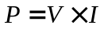 (2)
Using Ohm’s law given in (1), (2) can be reorganized
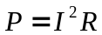 (3)
Or again using (1) and (2), we can also obtain
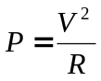 (4)
where ‘V’ is the voltage measured in Volts across the resistor in Volts, ‘I’ is the current measured through the resistor in Amperes, ‘R’ is the resistance in Ohms (Ω) an ‘P’ is the power calculated in Watts.

Energy dissipated over a resistor for DC excitation: For DC excitation, the power dissipated any device (probably a resistor) can be calculated using the formula,

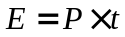 (5)
where ‘E’ is the energy dissipated (consumed) over the device in Joules, ‘P’ is the power dissipated in Watts by the device and ‘t’ is the time passed for DC excitation process in ‘seconds’.

- For the circuit in Figure 8 connect different R (two different resistors are used 1 kΩ and 10 kΩ) resistors with different nominal resistance values, measure the voltage and current values using multimeters (use analog multimeter as voltmeter and digital multimeter as Ampermeter) and calculate resistance, power and also energy values dissipated (for 60 seconds) then fill Table 5 according to your measurements and calculations.

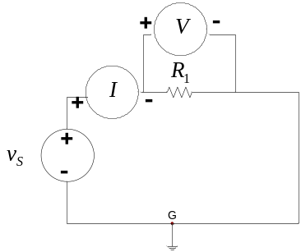
Figure 8: Circuit to measure voltage and current together.

Table 5: Measurement of all the quantities.
Measurement | No:1 | No:2
Resistance R (nominal value)
Voltage V (measured)
Current I (measured)
Resistance (calculated)
Power (calculated) 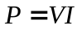
Energy dissipated in 60 seconds (calculated)

